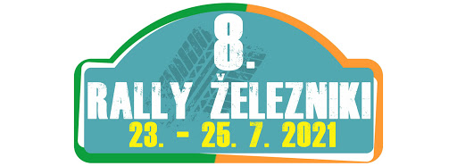

8. RALLY ŽELEZNIKI
Železniki, 23.07. – 25.07.2021

http://rally.omikronplus.si

AKREDITACIJSKI OBRAZEC / ACCREDITATION FORM

MEDIJ / MEDIA: ___________________________________________

IME IN PRIIMEK: / NAME AND SURNAME:
_________________________________________

TEL: _____________________________________

EMAIL: ___________________________________________

VAŠA VLOGA / YOUR ROLE AT EVENT: novinar fotograf TV

S podpisom se strinjam, da bom na 8. Rally Železniki sodeloval na lastno odgovornost. V nobenem primeru proti organizatorju, voznikom ali ostalim uradnim osebam ne bom vlagal odškodninskih zahtevkov.

I am fully aware that I participate at 8th Rally Železniki at my own responsibility. I will not take any legal charges towards organizer, competitors and other officials

KRAJ, DATUM IN PODPIS / PLACE, DATE AND SIGNATURE:

____________________________________

Obrazec poslati na naslov / To be sent to: info@omikronplus.si

